Name: ___________________________

1. Examine the following: Is the answer A, B, C, or D and why?

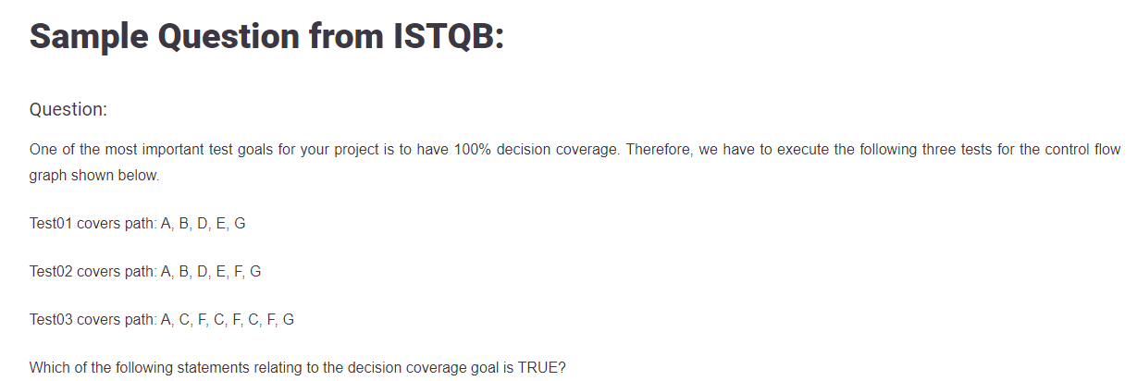

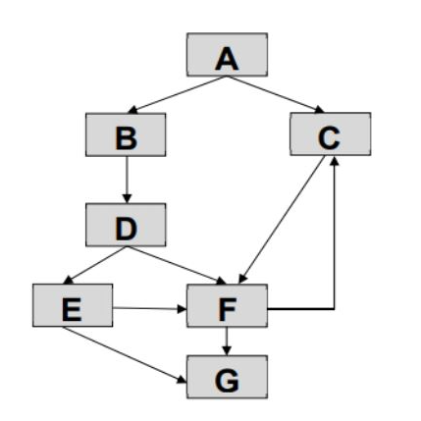

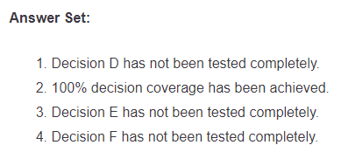

1. List all of the test cases you need to completely test the following. Use a decision table format:

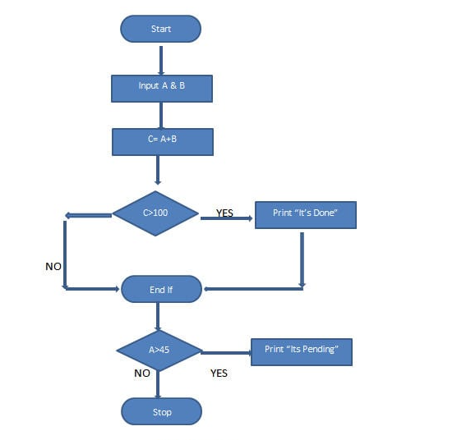

1. Write a decision table for the following requirement:

The ATM shall provide cash for a customer if, the customer’s account balance is > the amount requested or the customer has a pre-approved credit loan granted AND the machine has sufficient cash to make the payout.